HARCOURT BUTLER TECHNICAL UNIVERSITY



DARPAN PORTAL PROPOSAL BY 2nd YEAR TEAM

Under Supervision of

Respected Dr. Vivek Singh Verma

Darpan Portal Documentation

Introduction
Darpan Portal is an online platform designed to streamline the certificate request process for students. The portal integrates with the college's ERP system to facilitate online certificate requests and processing. This documentation provides an overview of the portal's features and functionalities from the perspective of faculty members.

Features

1. Authentication
- Login: Faculty members can log in to the portal using their credentials to access the certificate request data.

2. Certificate Requests
- View Requests: Faculty members can view all certificate requests submitted by students.
- Details: View detailed information about each request, including the type of certificate requested and the student's details.
- Verification: Verify the details submitted by students to ensure accuracy.

3. Status Updates
- Update Status: Faculty members can update the status of certificate requests to processing, rejected, or accepted.
- Communication: Communicate with students regarding their requests, if necessary.

4. Search Functionality
- Search: Easily search for specific certificate requests based on student details or request status.

Functionality Details

1. Authentication and Security
- Secure Login: Authentication system ensures only authorized faculty members can access the portal.
- Data Privacy: Ensures data privacy and security to prevent unauthorized access to student information.

2. Certificate Request Processing
- Request Handling: Faculty members can view and verify certificate requests submitted by students.
- Verification Process: Verify the details submitted by students to ensure accuracy and authenticity.
- Status Updates: Update the status of certificate requests based on verification results.

3. Communication
- Feedback: Provide feedback to students regarding their certificate requests, including reasons for rejection if applicable.
- Updates: Keep students informed about the status of their requests through the portal.

4. Search and Filter
- Search Functionality: Search for specific certificate requests based on student details or request status.
- Filtering: Filter requests based on criteria such as request type, student details, or request status.

5. Admin Panel

Default Django Admin Functions:
User Management: Create, update, and delete user accounts.
Group Management: Manage groups and assign permissions.
Site Management: Configure site settings.
Logging: View and manage logs for admin actions and system events.

Technologies Used
- Frontend: HTML, CSS, React
- Backend: Django, Django Rest Framework
- Authentication: JWT (JSON Web Tokens)

How to Use

For Students
- Select Document Field: Choose a document field (e.g., Duplicate Marksheet, Migration Certificate, etc.).
FIELDS :
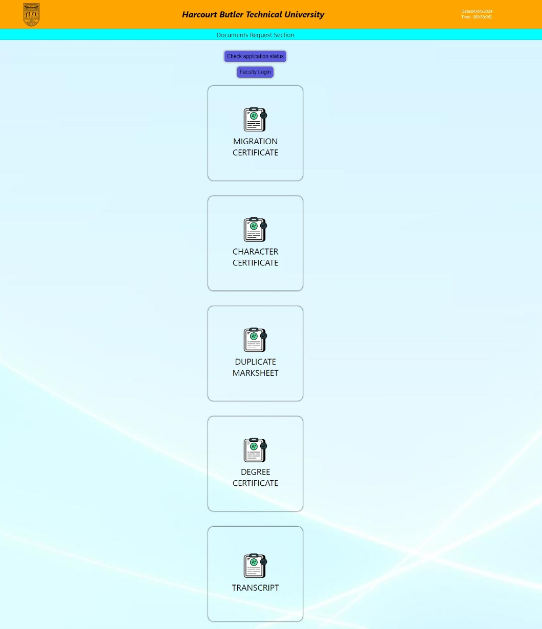

- Fill Form: Fill out the form with precise details.
Eg. Form
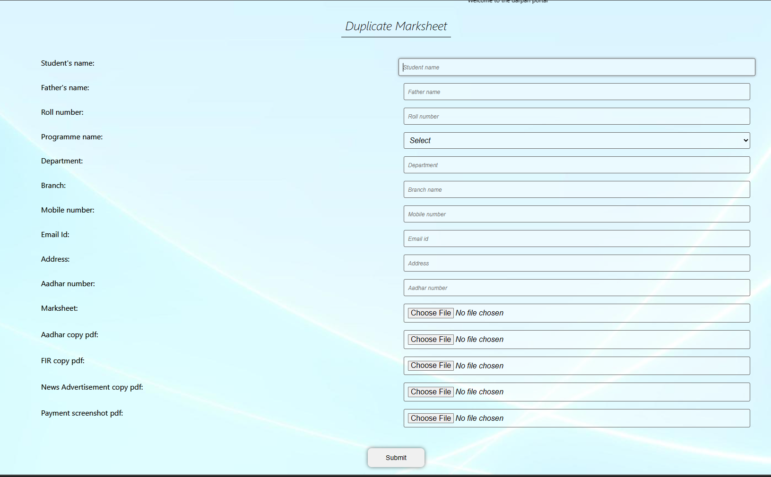
- Submit Request: Click the submit button to submit the request.
- Check Status: Go to the search bar, write your roll number, and view the status of your request.
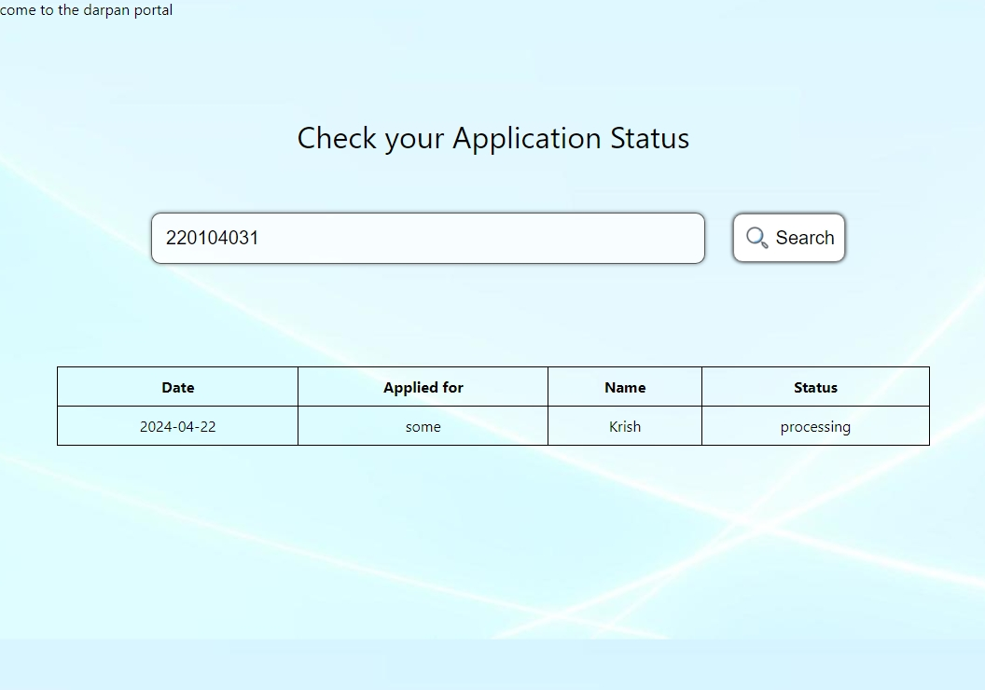

For Faculty
- Login: Log in to the faculty portal using your credentials.
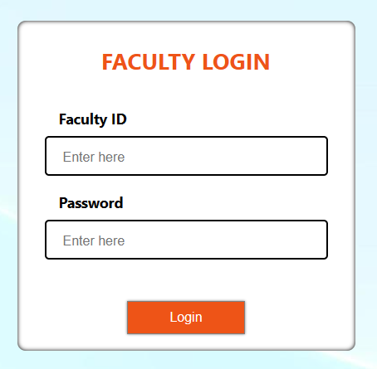
- View Assigned Documents: Only view document fields assigned to your department team.
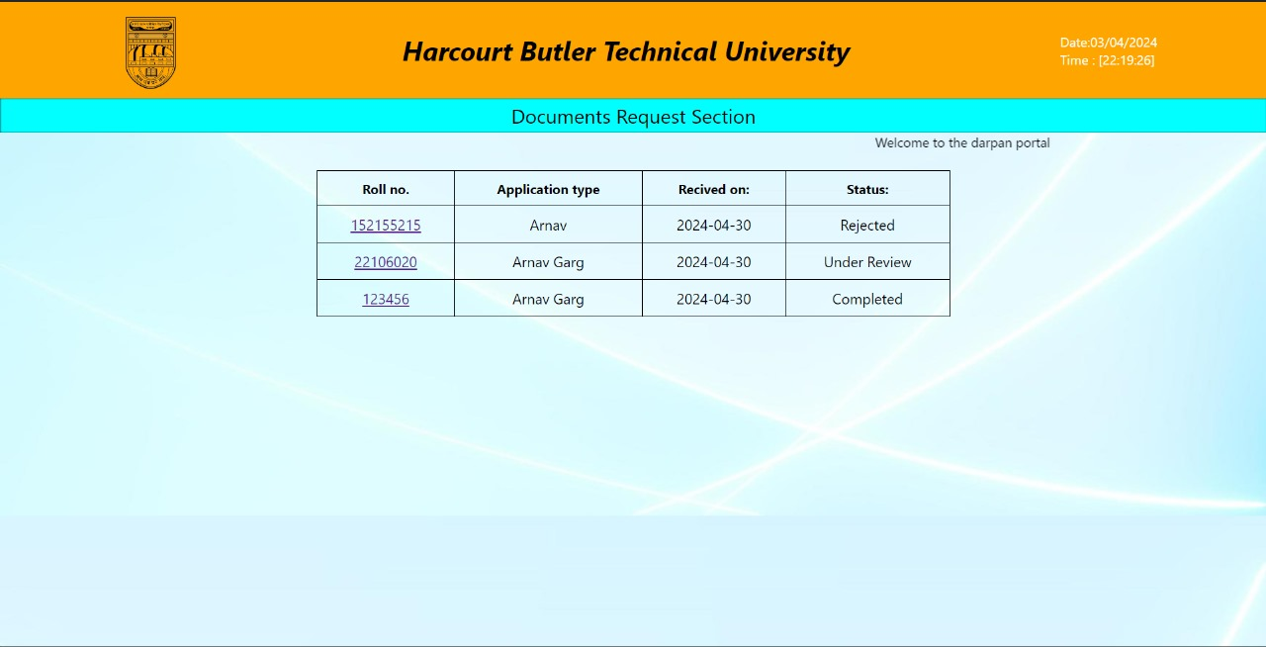

- View Request Details: Click on a request or search for a request in the search bar to view details filled by students.
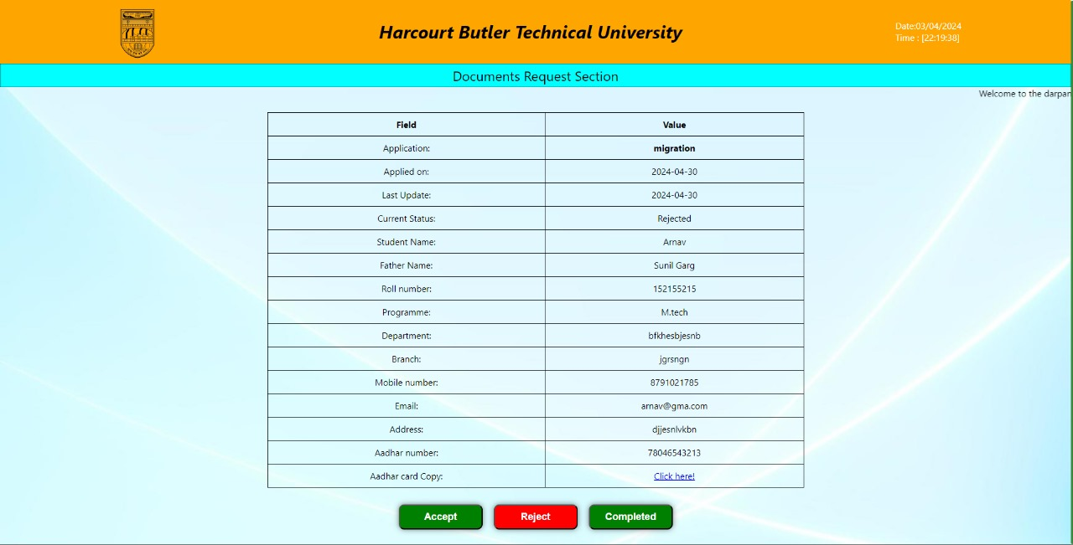
- Update Status: Update the status of requests by clicking Accept or Reject. This status update will also be shown to students.

Using the Admin Panel

Authentication:
Go to the admin login page (e.g., yoursite.com/admin) and log in using your admin credentials.
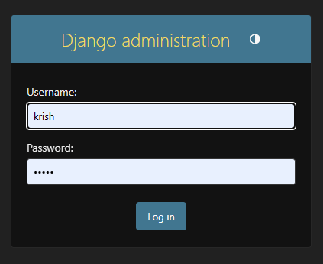

View Database:
Click on the "Details" database value to view the database entries.
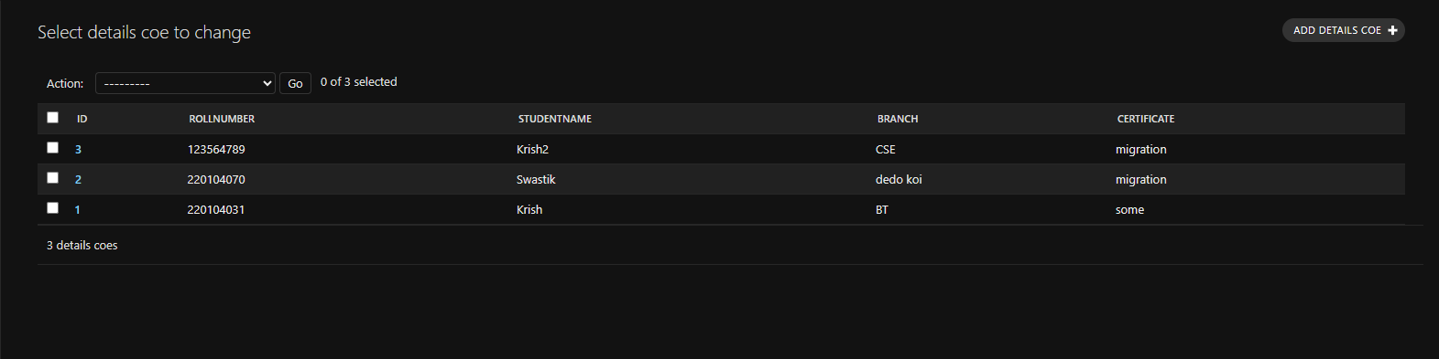

Modify Database:
You can modify any value in the database by clicking on the value and editing it directly.
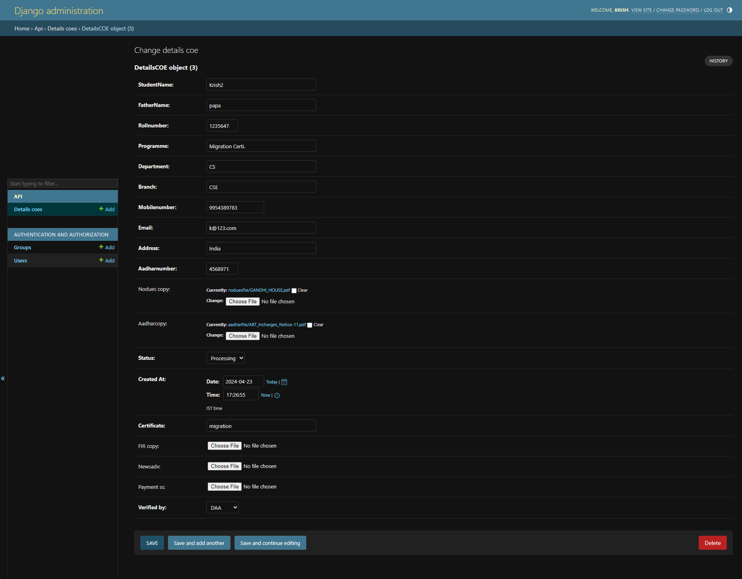

Conclusion
The Darpan Portal is a user-friendly platform that simplifies the certificate request process for students and provides faculty members with the tools they need to efficiently verify and process requests. By leveraging technology, the portal enhances the overall efficiency and effectiveness of certificate management within the college.

